# Things I need to figure out in the Canary Bank

## How to connect my tables

It seems like I have a few choices.

I can make my arrays in Javascript and use those and find a way to pass them to PHP.

I can try to make my arrays with PHP and then make them available to JS and work with them from there? I think one advantage to making the arrays in PHP is that I can do my createNewStudent function more simply. By keeping all those variables in PHP… can go through the class table, and find the corresponding teacher, use the array position to find the class name and class uid…?

Or no? it’s still hard. One thing I need to figure out is just passing some simple data between the two.. let’s make a table and an input now and try some things?

## How to send JS data to PHP using AJAX

Declare a variable. Do your process to it. Then make an AJAX request. Define the XML request data input as equal to the JS data variable.

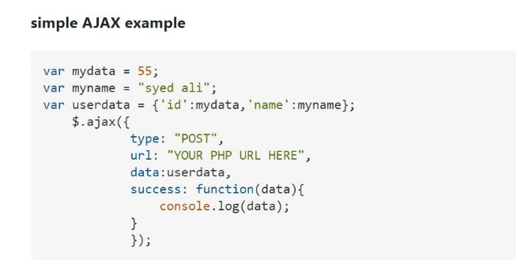

## Old stuff

Right now I’m having some trouble with updating my database. I know I can update the database more simply if I just use forms. But what about when I want to use a more interactive way to choose.

It is getting complicated but here are some things to address:

If I update a class list, will it add to the data that already exists, or will it overwrite the data. To test, I should make this more simple and get it all working with typing instead of complicating it with JS. Just go home, and set up the add class input form to connect to updateClassList.inc.php and have that push the the teacher’s “classNames” column. See if the old gets erased. Just make this work as a nice, clean professional thing for adults to use and help kids. Worry about the other stuff later. Just prove you can use the database and set up everything the way you want it. Even the students token amounts. That shouldn’t be so hard.

For the students, try to send to another page that will show the student’s profile pic and an interface for updating happy faces and tokens.

Or try to do it with your js variables.

But the main point is you need to stop trying to figure out how to do all the JS side of stuff and just isolate the interaction between your website and the server.

1. Figure out how to update existing data.. what I update the teachers classNames column will it rewrite the whole entry or just

**Ok** I’ve got it so that I can replace the old classes and class names in my database.. but not so I can add additional data to it. So how am I gonna make that work? I can always try with some JS now.. now that it works I can try to break it with some good old fashioned JS… prevent the default and now find out if I can make any changes. For example, input value = array.to.string + input.value

**Ok** I’ve unplugged a bunch of my JS stuff. I want to see how this works only with PHP. Just to get it working.

**Ok** I’ve got the class inputs working now. They successfully push to the database. The problem is that they are creating new entries with empty fields for all the other user/teacher information. I need to fix this so it sends the data to an existing teachers data cells.

**PROBLEM:** right now more than one classUid can exist if they exist on different teacher users. ***this has something to do with the fact that my classUids are stored as a string and not as an array… so it is reading the class id and not understanding that canary01, bluejay01 includes “canary01” in it and therefore the ID exists.

PROBLEM: there is something wrong with my add class form or functions.. because when I draw an error from the student sign up section, the PHP is working and the text “you forgot to fill in” is working in both the students and class sections. So I should differentiate them first.

PROBLEM: there is no classuid option for new students.